EED 206
(DIGITAL ELECTRONICS)

PROJECT REPORT

FIVE STATION
INTERCOM

SUBMITTED BY:

AKANKSHA KAUL: 1710110032
DANIEL DAVID VAZ: 1710110097
KABIR KANHA ARORA: 1710110165

FACULTY:

Dr NAVEEN G. BABU

(Signature)

ACKNOWLEDGEMENTS

Since you’re here, we’d like to take this opportunity to extend
our heartfelt gratitude to the university and Professor Naveen Babu
for a wonderful opportunity. We truly enjoyed the course and what it taught us.

We’d like to thank sir for his ceaseless support and
guidance throughout the course of the semester.

We would also like to thank Ashwani sir for his help in the lab.
This project would not have been possible without their able
guidance and expertise.

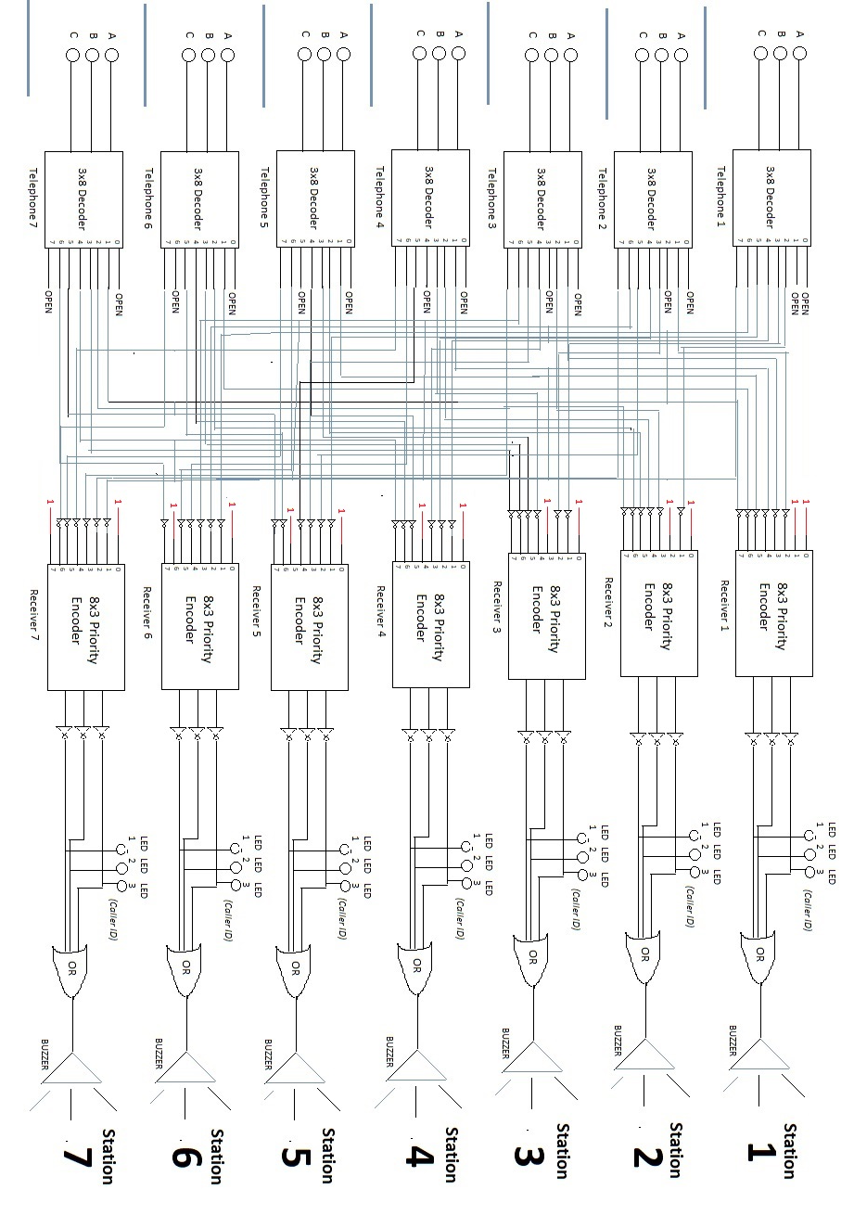
CIRCUIT DIAGRAM
Integrated Circuits (ICs) Used

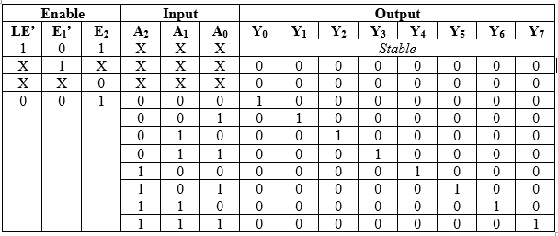
74HC237
(3x8 Decoder)

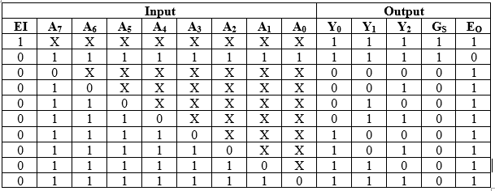
IC 74HC148
(8x3 Priority Encoder)

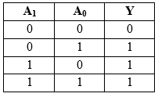
IC 74HC32
(Quad dual-input OR Gate)

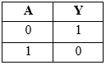
IC 74HC04
(6 dual-input NOT Gate)
Pin Connections of the ICs

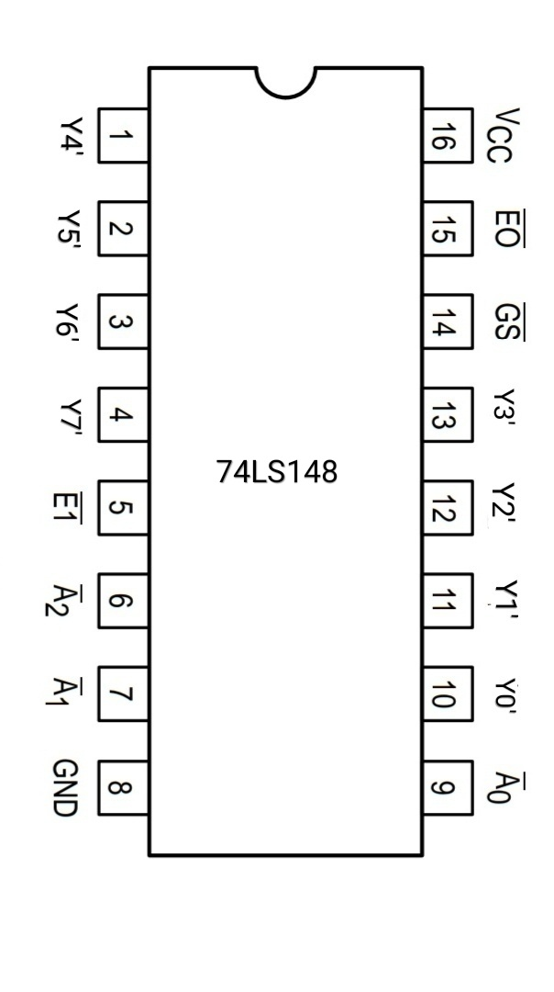
IC 74HC148
(8x3 Priority Encoder)

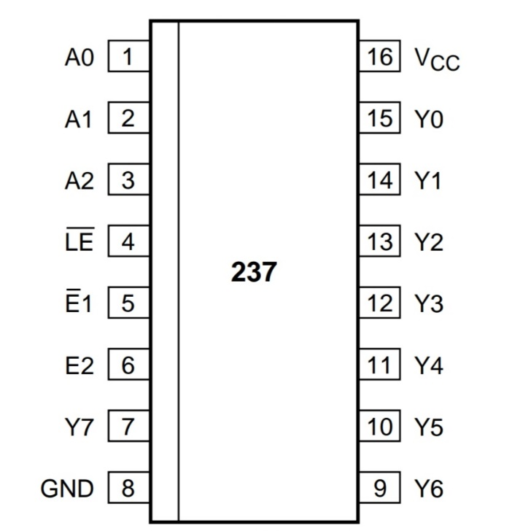
74HC237
(3x8 Decoder)

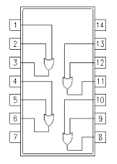
IC 74HC32
(Quad dual-input OR Gate)

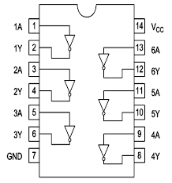
IC 74HC04
(6 dual-input NOT Gate)

Input-Output Combinations for each station

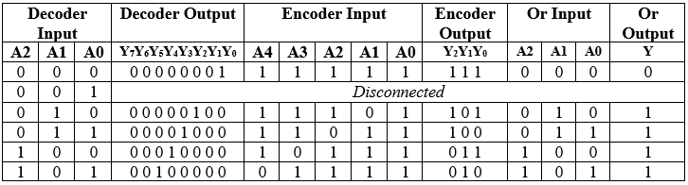
Station 1

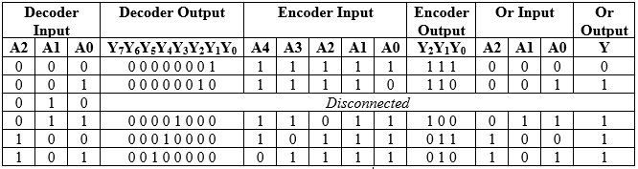
Station 2

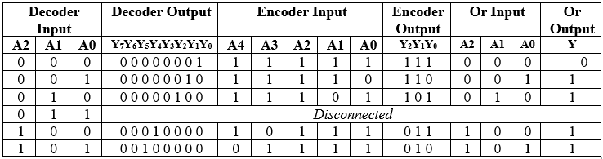
Station 3

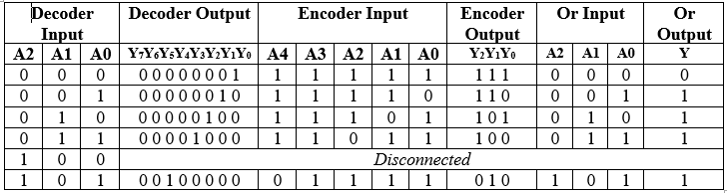
Station 4

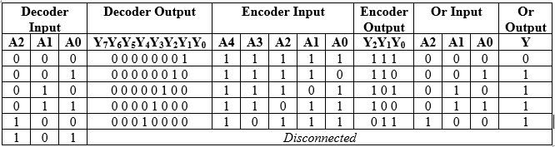
Station 5

Project Cost

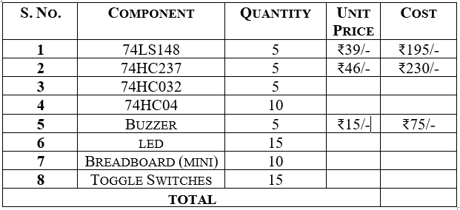

Input Switches

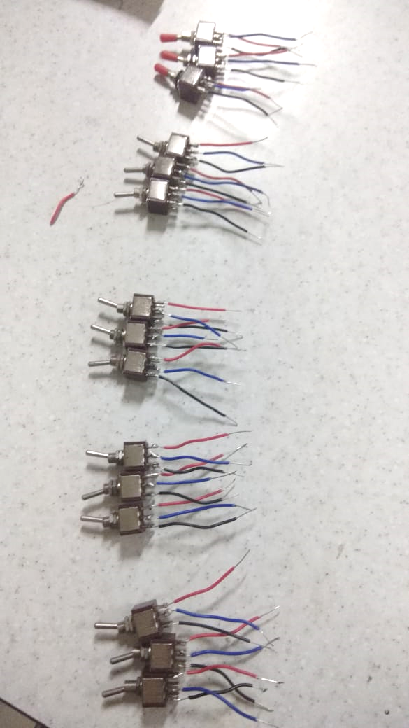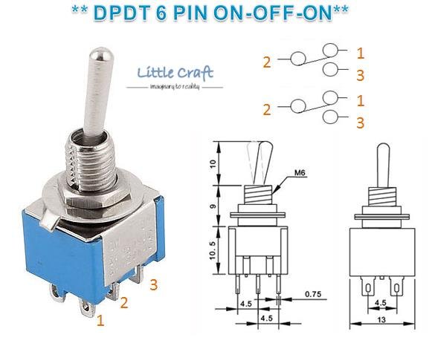
Our switches Pin Diagram for 6-Pin DPDT Dwitch

We used 15 6-Pin Double Pole-Double Throw (DPDT) Switches to give the input (calling) signals, using 3 switches per terminal.

SPDTs have three terminals: one common pin and two pins which vie for connection to the common.
Adding another pole to the SPDT creates a double-pole, double-throw (DPDT) switch. Basically two SPDT switches, which can control two separate circuits, but are always switched together by a single actuator.

Working Circuit

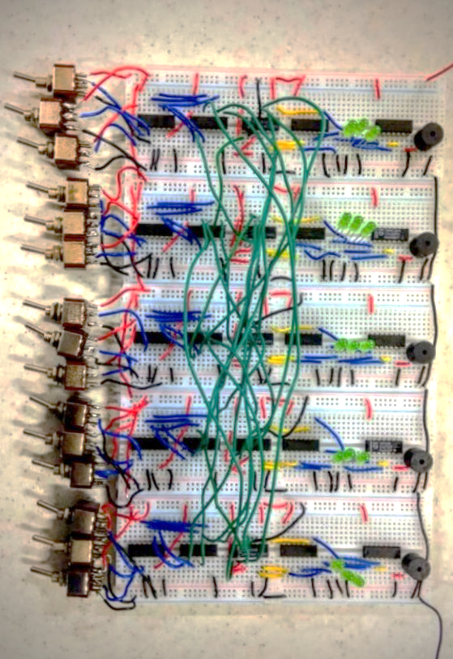

(Note: Due to an unexpected shortage of breadboards in the lab, we reduced our circuit to 5 stations instead of 7)

Design Challenges

One of the major challenges we faced initially was to come up with an original idea.
After a lot of brainstorming sessions, we came up with an idea to make an intercom. We can proudly state that the circuit design and implementation is 100% original and has in now was been copied from another source.
However, the sailing was not entirely smooth and we did have some hitches along the way. We did not take into account the fact that our Priority Encoder IC was based on Active Low logic and because of that, we had to remake the entire circuit after complementing all the inputs and outputs to and from the priority encoder, using NOT gates.
Soldering was a tough job and there were other things which we did for the first time and learnt along the way. The challenge was what made this project especially fun.

Conclusions

This being our first ever experience in designing and implementing an application of electronics on our own, was a fantastic learning curve. We spent long hours creating a prototype which we’re quite proud of, and we also understand that there can be quite a few additions and upgradations that can be made to it, for it to become a better product in itself. The hands-on experience helped us witness first-hand how the electronic components work and interact.

Overall, we thoroughly enjoyed the experience and feel a deep sense of satisfaction and pride in submitting our project and report.

Thank you.

